Contents

Overall Approach: 2

High Level Architecture Diagram: 3

Component Diagram: 4

Class Diagram 5

# Overall Approach:

In order to develop a scalable solution which can be integrated with enterprise communication and collaboration tools such as Teamworks (phonebook), Teams, Outlook etc. We designed and developed the APIs with an end goal to provide **Pronunciation as a Service**.

We finalized Microsoft Cognitive Services SDK that provides Text-to-Speech capability with a large data set of countries, voices and accents. The SDK has a dependency on Microsoft Azure subscriptions.

|  |  |
| --- | --- |
| **Component** | **Technology** |
| Polyglots WEB UI | React JS |
| Polyglots REST API | Java, Spring Boot |
| Database | Yugabyte DB |
| Platform | Microsoft Azure |
| Deployment | Docker Container |

For the purpose of providing a user interface during the Technology Hackathon, we have simulated the Teamworks (phonebook) UI.

# High Level Architecture Diagram:

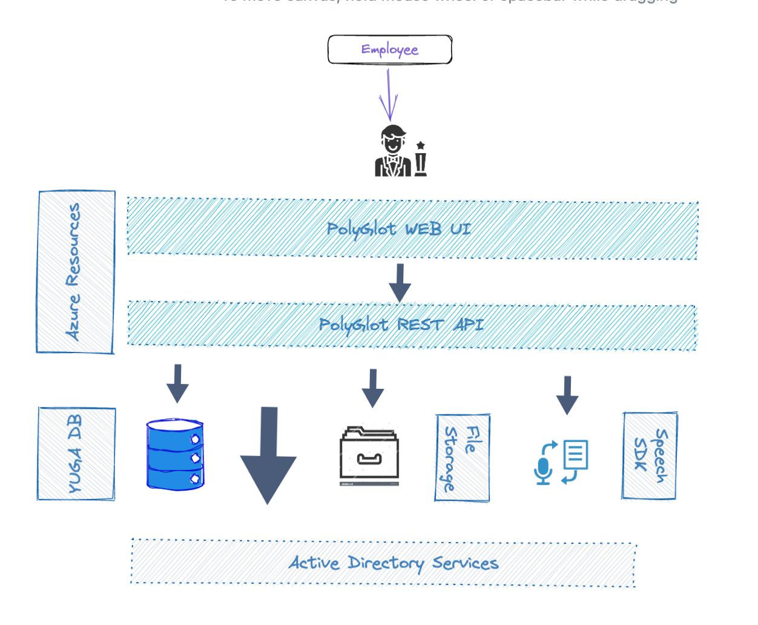

**Attachment**



# 

# Sequence and Traceability Diagram:

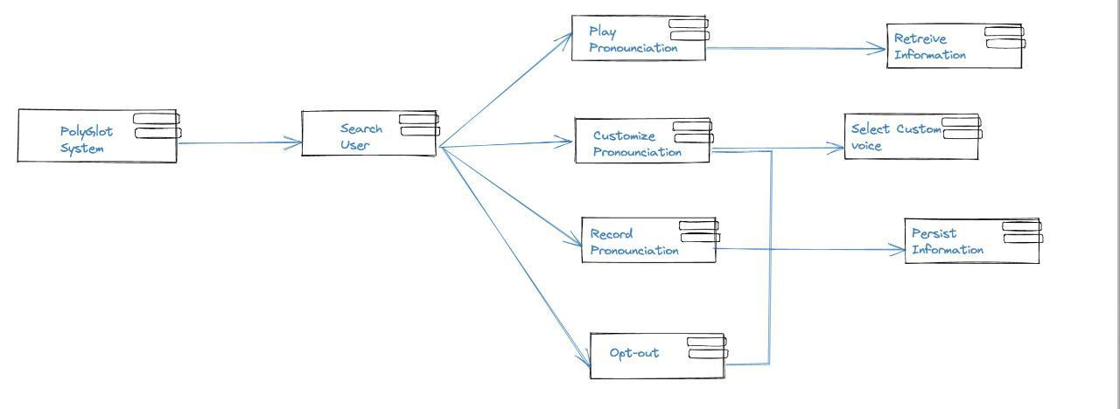

**Attachment**



Class Diagram**:**

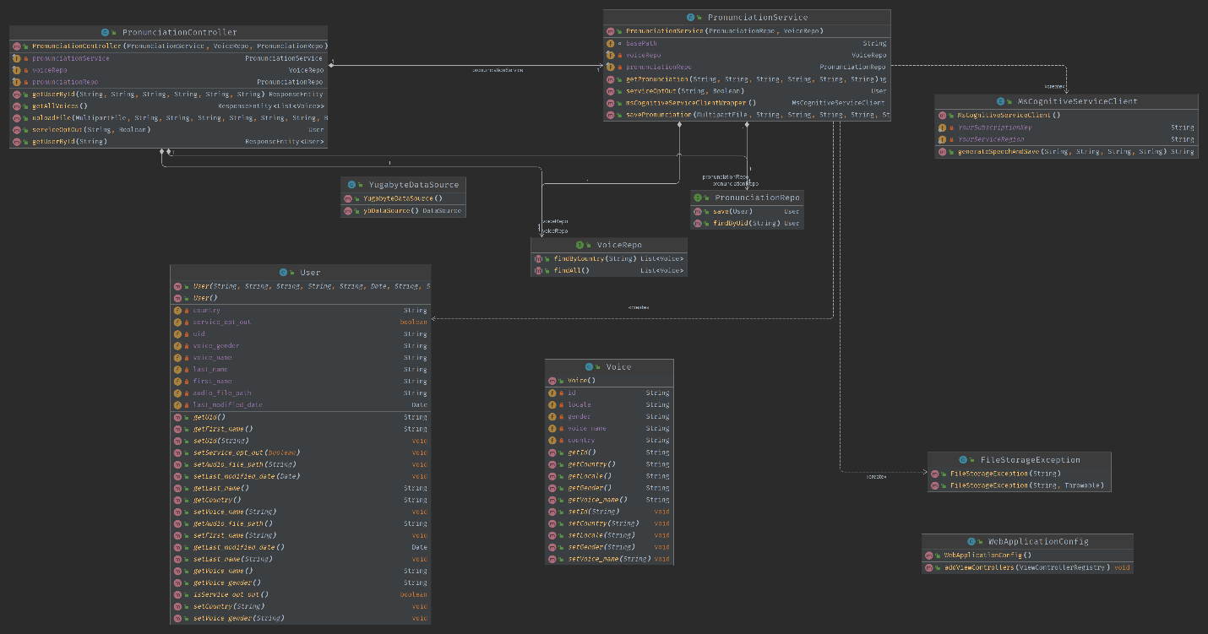

**Attachment**

